# Section 3: River Reversals and the Metabolic Regime of North Florida’s Springs

**Abstract**

Florida spring-runs are typically perceived as chemostatic systems due to stable thermal, hydrologic, and chemical conditions. However, they can experience flood-like disturbances, known as backwater floods, due to interactions with downstream river stage fluctuations. These disturbances range from high-stage events (slow flow) to brownouts, where downstream river water mixes with spring-run water, and flow reversal, where spring water is displaced by river water. These floods impact benthic light availability by altering water depth and clarity, influencing spring-run gross primary production (GPP) and ecosystem respiration (ER). To understand these impacts on spring-run productivity and resilience, we measured metabolism and CO2 dynamics in five spring-runs along a reversal frequency gradient. Normal stage conditions supported higher GPP, lower ER, elevated dissolved oxygen (DO), and lower CO2 concentrations compared to high-stage events. Spring-runs enduring prolonged brownouts experienced reduced GPP, increased ER, anoxic conditions, and elevated CO2 levels. Even less severe high-stage events substantially altered spring-run metabolism, showing a consistent negative relationship between stage and net ecosystem productivity (NEP) among spring-runs. However, GPP, ER, DO, and CO2 returned to normal faster than hydrological conditions, indicating resilience. These findings highlight the significant impact of flood events on spring-run metabolism and the creation of ecological bottlenecks through extended hypoxic conditions. While spring-run ecosystems differ from typical river floods due to slower or reversed flow, the observed effects on metabolic regimes likely extend to other systems.

This suggests that spring-run ecosystems encompass a range of flow regimes, from chemostatic spring- runs to those vulnerable to highly consequential flooding.

**Introduction:**

Stream metabolism is a key ecosystem function serving as the basis of lotic food webs, carbon cycling, and water quality. Metabolism in flowing waters varies in response to a host of energetic, hydrologic, and ecological drivers (Bernhardt et al., 2018). The emergent patterns of temporal metabolic variation – specifically in gross primary production (GPP), ecosystem respiration (ER) and net ecosystem production (NEP = GPP + ER) – describe the metabolic regime, reflecting the idea that lotic ecosystems subject to known drivers yield predictable inter- and intra-annual metabolic patterns. The dominant controls on metabolic regimes in flowing waters appear to be energy inputs (light, organic matter) and disturbance (Bernhardt et al. 2022). Light limitation is a dominant control on metabolism (Kirk et al., 2021) because light availability is strongly attenuated by canopy cover and flow-related changes in water depth and clarity (Bernhardt et al., 2019; Hall et al., 2015; Julian et al., 2008; LeRoy Poff et al., 1997).

Organic matter supply impacts ecosystem heterotrophs, with a complex blend of autochthonous and allochthonous sources controlling organic matter availability and bioavailability, as well as ER in flowing waters (Bertuzzo et al., 2022). Finally, disturbance is thought to control metabolism in flowing waters by scouring the riverbed, removing biomass of both autotrophs and heterotrophs along with organic stocks (LeRoy Poff et al., 1997). As such, disturbance serves as a governing control, affecting metabolism through various mechanisms. It alters light inputs by influencing water clarity (Bernhardt et al., 2019; Hall et al., 2015; Hosen et al., 2019), changes the supply and export rates of organic matter (Bertuzzo et al., 2022; Biggs et al., 1999), modifies nutrient availability, and removes the biota necessary for performing metabolic functions (Acuna et al., 2005; Bernhardt et al., 2018). Depending on disturbance frequency, duration, and severity, permanent shifts in productivity and respiration regimes can occur (Baker & Walford, 1995; Heffernan, 2008). The importance of flood disturbances is considerable, with rivers with more stable flow regimes exhibiting far more stable metabolic regimes and higher GPP than those routinely exposed to flow disturbances (Bernhardt et al., 2019, 2022). However, whether the reduction in light availability, the influx of organic matter (OM), or biomass loss via bed scour drives the magnitude of disturbance impact on metabolic regimes is unexplored.

North Florida’s spring-fed rivers are among the most productive lotic ecosystems in the world (Duarte et al., 2010; Odum, 1956). Water from upper Floridan aquifer (UFA) is delivered with low temporal variation in flow or chemical composition (Fernald & Purdum, 1998; Jawitz & Mitchell, 2011) and exceedingly high clarity and low dissolved organic matter (DOM) (Duarte and Canfield 1990), yielding conditions famously referred to as chemostatic (Odum, 1957). That is, the many iconic springs that have received research attention lack pulse disturbances due to flooding, creating ecosystems that can sustain high benthic biomass (King, 2014) and extremely high rates of GPP (Kirk et al. 2021).

The archetype of “chemostatic” North Florida springs, yielding a widely invoked endmember of riverine metabolic regimes emerges from studies conducted on a select number of large stable springs with long spring-fed rivers (e.g., Odum 1956, John 2006, Heffernan et al. 2010, Hensley et al. 2014). These are largely isolated from interactions with the downstream rivers, limiting or even eliminating the frequency and severity of backwater floods. The concept of springs as 'nature's chemostat' (Odum, 1957) is a long-standing idea that is applicable to springs with long runs situated far from a downstream blackwater river. However, it may not be relevant to springs with short runs located near their receiving river. Indeed, springs more proximate to flood-prone blackwater rivers experience more frequent and severe disturbances when high flows occur in those downstream rivers and create a backwater effect or even reversal conditions in spring flow (Brown et al., 2014; J. Gulley et al., 2011; Hensley & Cohen, 2017) with potentially important management and ecological implications. During these backwater events, spring stage rises (hindering light penetration), flow slows or halts (decreasing gas diffusion), and OM supply is elevated changing the energy basis of the ecosystems (Hall et al., 2016; Hall & Ulseth, 2020, Heffernan & Cohen, 2010). This creates a notable contrast with flood effects in other rivers where light availability impacts are similar, but stage and velocity are positively correlated. Flood magnitude is dependent on a spring’s distance from the river, run length, and spring-river hydraulic gradient with near-river springs being the most susceptible (Donsky, 2023). These "backwater floods" encompass a spectrum of conditions. They range from high stage events (hhigh), where the aquifer water in the spring- run persists but at greater depth and reduced flow velocity, to brownouts (hbrown), during which tannic river water mixes into the spring-run, and even flow reversals (hreversal), where tannic river water completely displaces the spring water. Given the striking differences in water character between the spring-runs (clear, alkaline, low oxygen, and DOM) and their tannic downstream waters (darkly stained, acidic, high oxygen, and DOM), mixes with, or replaces entirely, the alkaline, clear, aquifer water (Brown et al., 2014; Hensley et al., 2015; Hensley & Cohen, 2017).

The lack of bed scour during backwater flooding in spring-runs is clearly atypical of rivers and streams. In spring-run floods, the flow interruptions involve slowing, halting, or reversing, but not quickening as seen in stream floods. While both types of floods lead to alterations in light and energy input due to increased water depth and reduced clarity, a key distinction is that spring-runs retain their benthic biomass and organic matter during floods, whereas streams lose benthic biomass and organic matter through bed scouring. Few studies have explored the transient river-spring water interactions that occur during backwater floods, nor have they observed river reversal (RR), hbrown and hreversal, metabolic impacts.

Given the variability that exists in the disturbance regimes across spring-runs, and the potential role that disturbance plays in regulating the structure and function of these important ecosystems, we sought to improve understanding of spring metabolic regimes across a gradient of flood impacts. We tested five linked hypotheses: 1) GPP will decrease, and 2) ER will increase with increasing stage and decreasing flow velocity, regardless of reduced clarity. Similarly, I hypothesize 3) spring metabolism will decline with increased light attenuation, despite the absence of bed scour, and 4) backwater flood magnitude (duration, change in stage) will be positively correlated with metabolic recovery time and metabolism reduction (increase in ER, decrease in GPP). Lastly, 5) I hypothesize frequently disturbed springs will have metabolic regimes with more variation than rarely disturbed springs. By assessing how flood disturbances impact the metabolic function of springs, this work can provide insights into the extant variety that may be overlooked in these iconic flowing ecosystems and quantify the consequences of changing flood disturbances on their future metabolic regime.

**Methods:**

**Study Sites:**

To evaluate impacts of backwater floods on metabolic regimes, I estimated GPP, ER, and NEP in spring-runs that span a gradient of flood frequency and severity. Each spring has a sufficiently long run (>300m) to estimate diurnal variation in DO departing from the constant boundary conditions assumed at the spring vent. Flood risk was determined based on proximity to receiving river and the elevation difference between the spring vent and spring confluence. I chose two springs that frequently flood (Allen Mill Pond – AM, Otter Springs – OS), three that flood infrequently (Little Fanning – LF, Gilchrist Blue – GB, and the downstream reach of Ichetucknee River – ID), and finally one spring that almost never floods (the upper Ichetucknee – IU) (Figure 2-1). The storage in the sink-rise system of the Santa Fe River attenuates hhigh and hbrown, buffering GB and other Santa Fe springs from the effects of regular floods (J. D. Gulley et al., 2014). While Ichetucknee is also on the Santa Fe River, it is far closer to the confluence with the Suwannee River, with floods from that river back-propagating to create backwater floods in the springs along the lower Santa Fe River.

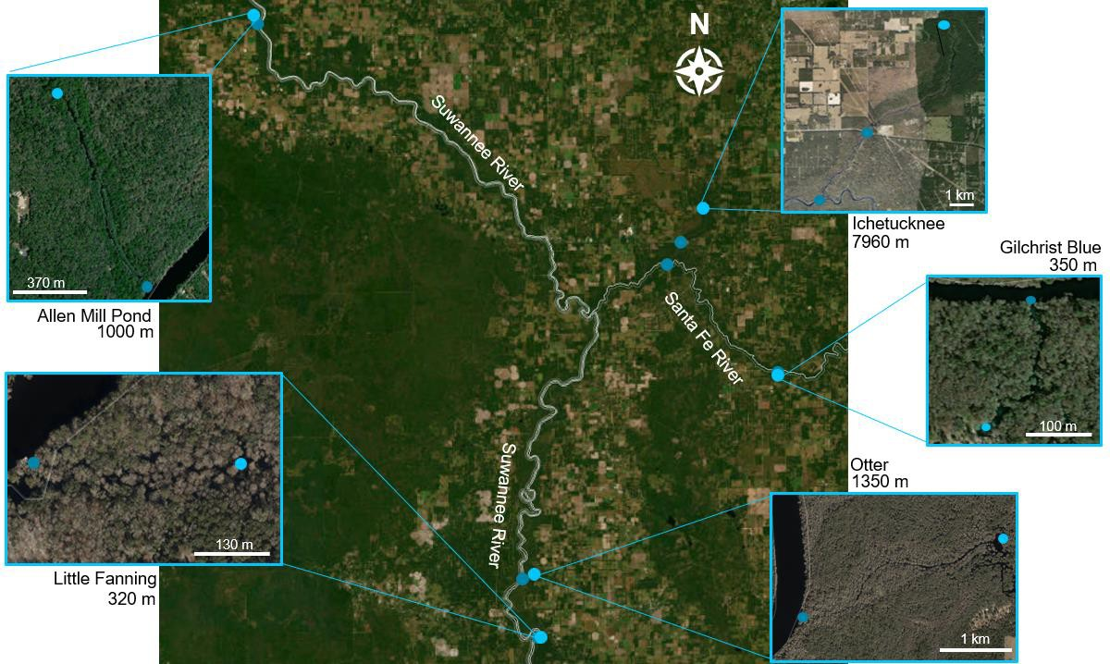

*Figure 1: A map of sites along the Suwannee and Santa Fe River. Five spring-runs were selected spanning gradient of river reversal frequency. The least disturbed sites included Ichetucknee Up, Gilchrist Blue (GB), Ichetucknee Downstream (ID), and Little Fanning (LF). More disturbed sites included Otter Spring (OS) and Allen Mill Pond (AM).*

**Ecosystem Metabolism:**

I collected high-frequency data for dissolved oxygen (DO) and stage in each spring, except for IU, which was not included in the metabolic flux estimation. To capture these measurements, I used an optical DO sensor (Onset HOBO U26-001, Onset Computer Corporation, Massachusetts, USA) and a high-resolution pressure transducer (Onset HOBO U20-001-04), logging data hourly for both flood- disturbed and non-disturbed conditions. Recognizing the distinct differences between the tannic, acidic water from river floods and the clear, alkaline aquifer water usually found in the spring-runs, I deployed specific sensors to track these variations. These sensors included a specific conductivity (SpC) sensor (Onset HOBO U24-001), a pH sensor (Onset HOBO MX2501), and a Fluorescent Dissolved Organic Matter (FDOM) sensor (Cyclops-7F, Turner Designs, Inc., San Jose, CA). These instruments were crucial for documenting changes in source water characteristics and distinguishing between undisturbed periods (hnorm), high-stage events (hhigh), brownouts (hbrown), and true flow reversals (hreversal). SpC was especially key in detecting source water changes due to the marked difference between the low-conductivity floodwaters and the highly conductive, carbonate spring water. Furthermore, I co-deployed a dissolved CO2 sensor (Eosense eosGP, Eosense Inc., Dartmouth, NS) to gather additional data on water sources and metabolic fluxes. This included insights into changes in source water and the significance of anaerobic processes. For IU, I utilized publicly available data from the USGS National Water Information System (NWIS) portal over the same period. It's important to note that this time series from IU did not include CO2 measurements.

**Two-station Metabolism:**

Four pathways influence DO dynamics, and thus the inference of NEP: 1) aquatic autotrophs releasing oxygen (GPP), 2) O2 consumption via respiration (ER), 3) exchange of O2 with the atmosphere (Din), and 4) groundwater influence accrual (Ac) (Demars et al., 2015; Kirk, 2020; Odum 1957; Reichert et al., 2009; Riley & Dodds, 2013). Changes in DO concentrations yield the following equation for NEP:

𝑑𝐶𝐷𝑂 = 𝑁𝐸𝑃 + 𝐷𝑖𝑛 + 𝐴𝐶

𝑑𝑡𝑧 (2-1)

Where *dCDO /dt* is the change in DO concentration over time (g O2 m-3 hr-1), and *z* is mean water column depth (m). The atmospheric gas exchange flux, *Din* (g O2 m-2 hr-1), is the product of the gas exchange velocity (*K*, m hr-1) and the DO saturation deficit (*CSat.Deficit* = *Csat - CDO*, g O2 m-3), the above equation can be rearranged to:

|  |  |
| --- | --- |
| 𝐶𝐷𝑂(2𝑖) − 𝐶𝐷𝑂(1𝑖)  𝑁𝐸𝑃𝑖 = ∆𝑡 − 𝐾 ∗ 𝐶𝑆𝑎𝑡𝐷𝑒𝑓𝑖𝑐𝑖𝑡(𝑖) ∗ 𝑧 | (2-2) |

For one-station metabolism, *Δt* is time step, and *CDO(2i) - CDO(1i)* is the change in DO over each time step. For two-station metabolism, *Δt* represents travel time, accounting for stream surface area, between an upstream and downstream location, and *CDO,2i-CDO,1i* represent the change in DO between two locations (a constant upstream boundary condition *CDO,1i*). Metabolic reactions that generate O2 contribute to a positive NEP, whereas reactions that consume DO and produce CO2 result in a negative NEP. I calculated ER using nighttime NEP values, assuming negligible GPP during the night. This approach allowed me to estimate daily GPP by calculating the cumulative difference between NEP and ER over the course of the day.

I primarily used the two-station method to model NEP where *CDO,2i-CDO,1i* is the DO concentration difference between an upstream station and downstream station. This approach is desirable because it isolates the signal created by a specific stream reach (Demars et al., 2015). Use of two-station metabolism in spring-runs is further warranted because the upstream boundary condition (at the spring vent) is nearly always well below saturation, which would be interpreted by a one-station model as high respiration. However, if the reach length, *L* between stations (m) is longer than *0.4u k-1* (*u*= velocity m h- 1; *k* = gas constant h-1), the two stations are assumed independent, and one-station metabolism assumptions are viable (Reichert et al., 2009; Riley & Dodds, 2013). Conditions at OS consistently violated this two-station length threshold, so one-station methods were applied. Since IU data was collected from NWIS and there are no other stations recording hourly DO upstream from IU, one-station methods were conducted on this site. During backwater floods, when velocity declines markedly, AM, LF, and GB violated the two-station length threshold and one-station methods were applied.

Sensors were serviced every two weeks, during which a DO sensor was deployed at the head spring to measure the boundary condition concentrations. During normal flow conditions, we assumed groundwater at the spring vent was chemically constant, such that vent-water DO concentrations were applied to estimate boundary concentrations (*CDO,1*) for the two weeks between field servicing.

Our two-station metabolism model was implemented in R using protocols and methods from Demars et al. (2015), Kirk (2020), Marzolf et al. (1994), Odum (1956), and Young et al. (1998). One- station metabolism was estimated using the *streamMetabolizer* package in R with Bayesian parameter pooling of the reaeration coefficient (*k600*) as a function of discharge (velocity*width*stage) (see below) (Appling et al., 2018; github.com/USGS-R/streamMetabolizer).

**Estimating Gas Exchange:**

The gas exchange velocity, *K* (m d-1), quantifies how gases move between the water and atmosphere (Hall and Ulseth, 2019). It can also be reported as a reaeration coefficient, *k* (d-1), which is *K* divided by stream depth. To estimate the gas flux, I multiplied *k* by the *CSat. Deficit* and daily stage. Since reaeration rates vary across gases, *k* is typically normalized using Schmidt scaling coefficients and reported as *k600* (d-1) (Hall & Ulseth, 2020; Kirk, 2020)*.*

I estimated *k600* empirically using floating domes conducted biweekly at each site (Copeland & Duffer, 1964). The floating dome is an inverted plastic container yielding a head-space volume of 15.5 L. I used a high frequency (1 sample per minute) CO2 sensor deployed in the headspace to track CO2 concentrations over time following a pulse to increase headspace internal concentrations far above river water concentrations. I tracked headspace pCO2 over ~15 minutes and calculated the rate of air-water equilibration, adjusting for surface area. Stream surface water velocity (*u*) was measured adjacent to the gas dome using an orange.

Following Khadka et al., (2014) and McDowell & Johnson, (2018), *kCO2*, the reaeration coefficient for CO2, was estimated by fitting a linear regression between time and the partial pressure of CO2 (pCO2). The flux in CO2 (ppm min-1), or *ΔCO2* was converted to mol day-1 using the ideal gas law:

|  |  |
| --- | --- |
| 𝑛 ∆𝐶𝑂2  =  𝑡 𝑅𝑇 | (2-3) |

Here n/T (mol/time) is CO2 mols per day, *ΔCO2* is the slope of pCO2 vs time, R is the ideal gas constant (0.0821 L atm K-1 mol-1), and T is air temperature (K). *kCO2* was then solved with:

|  |  |
| --- | --- |
| 𝑛 −1  ( 𝐹𝐷 )  𝑘𝐶𝑂2 = 𝑡 𝑧−1  𝐾𝐻 ∗ 1000 ∗ (𝑝𝐶𝑂2𝑤𝑎𝑡𝑒𝑟 − 𝑝𝐶𝑂2𝑎𝑖𝑟 ) | (2-4) |

Where *FD* is the floating dome footprint (m2), KH is Henry’s law constant adjusted for temperature (moles per atmosphere), *pCO2, water* is the pCO2 of the water column during the experiments (ppm) and *pCO2, air* is the peak concentration of CO2 within the gas dome. *kCO2* was converted to *k600* (d- 1) with Schmidt scaling (~ 585):

|  |  |
| --- | --- |
| 2  600 3  𝑘600 = 𝑘𝐶𝑂2 (𝑆𝑐ℎ𝑚𝑖𝑑𝑡 𝐶𝑂 )  2 | (2-5) |

Using our field measurements of *u* and *h*, I developed a rating curve for *k600* (day-1) to allow continuous estimates for each day. First, I related *u* and *h* from which I extracted a relationship to estimate velocity from continuous stage measurements. I then regressed the ratio of *u/h* vs. measured *k600* to establish the continuous variation in gas exchange at each site for use in metabolism models (Figure 3-2). During flow reversals (*u*<0), I used the absolute value of *u* to estimate *k600*. To provide confidence the *k600* rating curve was representative, I compared the rating-curve estimates with Raymond et al. (2012), John et al. (2006), and Knight (1980) model outputs.

**Spring Stoichiometry**

Ecosystem production and consumption of DO and CO2 on a molar basis are generally expected to yield concentrations that covary along the -1:1 slope. The stoichiometric quotients for photosynthesis (PQ) and respiration (RQ) are broadly assumed to be 1.0, even though evidence has accumulated for values that can depart significantly. Given the broad expectation of 1:1 coupling, plots of the temporal patterns of O2 vs. CO2 can be used to infer biogeochemical functions about ecosystems (Vachon et al., 2020), including sources of water, which can decouple concentrations of DO and CO2, mineral dissolution reactions, which can consume or produce CO2 without affecting DO, or anaerobic respiration, which yields CO2 without consuming DO. I plotted O2 and CO2 departure from atmospheric equilibrium (Bernal et al., 2022; Vachon et al., 2020) yielding “cloud points” of hourly changes in O2 (mol L-1) in relation to CO2 (mol L-1); to visualize the effects of floods, I color coded the dots by flood stage conditions. I further assessed the coupling of these metabolic gases by estimating the daily slope between O2 and CO2 to assess departure from a slope of -1 with changes in flood conditions.

I converted DO mg L-1 and CO2 ppm to mol L-1. Aqueous CO2 (ppm) was transformed to mol L-1 using the ideal gas law. DO (mg L-1) was converted to mol L-1 using the molar mass of 16 g mol-1. DO saturation based on water temperature was calculated in R using *streamMetabolizer*. Daily slopes of DO vs. CO2 coupling were calculated using *dataEllipse* (https://rdrr.io/cran/car/man/Ellipses.html). Days with positive slopes were removed.

.

**Reduction, Recovery, and Stability of Flood Stage Metabolism:**

Flood effects of ER and GPP include changes in fluxes in response to flood magnitude, and persistent effects after the flood has abated (i.e., relative recovery times). To assess these metabolic responses to flood stage conditions, I calculated the changes in NEP, ER and GPP, the recovery times to return to pre-flood metabolic rates after peak-disturbance, and the overall temporal stability of the metabolic regime.

**GPP and ER Reduction:**

Changes in productivity were assessed by dividing spring stage conditions into 1) normal baseflow (hnorm) and 2) high stage periods (hhigh). The delineation of hhigh was determined from the left skew of stage histograms which revealed a second mode of river stage associated with each flood. The local minimum between modes was defined as the threshold, with lower stages corresponding to hnorm and higher stages corresponding to hhigh (Figure 2-2). GPP and ER for hnorm were averaged and considered baseline GPP and ER. Disturbance events were isolated from the time-series, and mean GPP and ER during peak flooding (5 days before and after stage reached its maximum) were averaged (GPPdisturbance). The relative change in GPP was estimated as *1- (GPPhnorm / GPPdisturbance*) (Reisinger et al. 2017). This was repeated for ER, and across every disturbance, tracking the magnitude of each flood based on the stage excursion from normal condition. To test whether disturbance magnitude significantly impacted GPP and ER, I regressed change in stage (Δh) against the GPP and ER percent reduction.

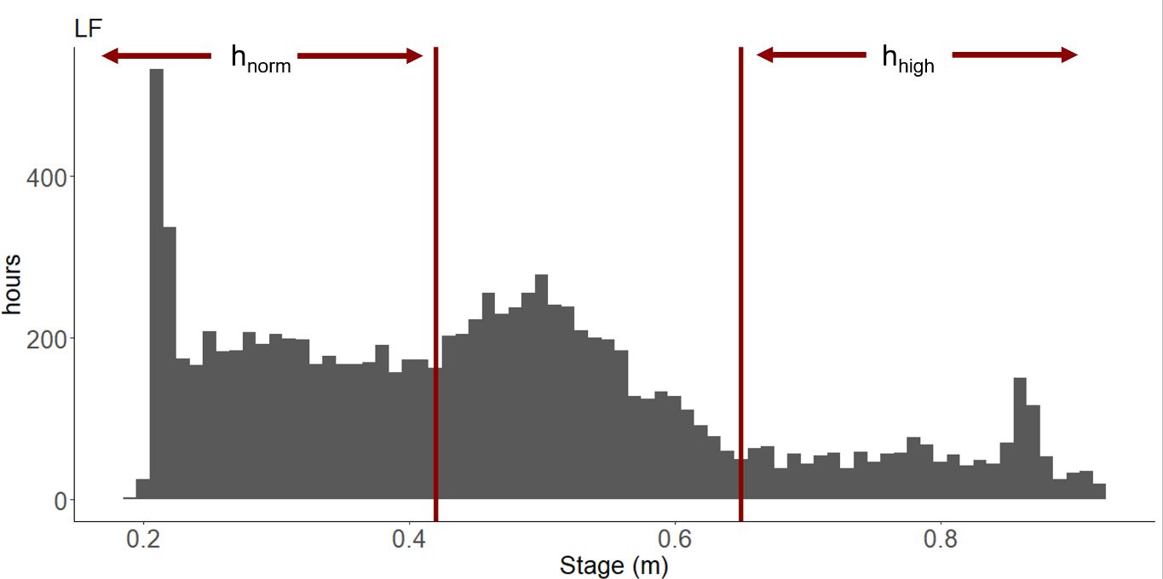

*Figure 2: Disturbed and undisturbed periods were distinguished by utilizing stage histograms. These histograms displayed a bimodal distribution, with a local minimum between the modes defining the threshold (indicated by the red lines). Lower stages were associated with undisturbed periods, while higher stages were associated with disturbed periods. The disturbed periods were further categorized into high-stage events (hhigh), brownouts (hbrown), and flow reversals (hreversal) based on their SpC, FDOM, and pH readings.*

**GPP and ER Recovery:**

Quantifying patterns of metabolic recovery were inspired by Martí et al., (1997) and Reisinger et al., (2017). First, disturbance events, and two weeks prior and after, were isolated from the time-series. The stage, GPP, and ER for the ~7 days before the reversal were averaged and considered baseline metabolic activity. Disturbance stage, GPP, and ER were divided by baseline stage, GPP, and ER creating a disturbance ratio for each day where 1 equals pre-disturbed GPP or ER. These were then smoothed by applying a rolling means function in R (*rollapply*) that calculated the mean for every four consecutive days. Once each component’s time-series reached ~1 or plateaued, the component was deemed recovered. A linear regression was fit between the disturbance ratios versus time to determine the recovery rate, resulting in a *y=mx+b* equation. Using the *y=mx+b* equation, I set *y=1* and solved for *x* to approximate how many days would be required for full recovery.

GPP and ER recoveries were divided by their correlating stage recovery to create recovery ratios. High stage events (hhigh) were differentiated from river reversals, river water intruding into the spring- run (hbrown or hreversal), using time series of FDOM (FDOM > 7 ppb QS), and SpC (threshold of < 200 μS cm- 1), along with field observations. Periods with elevated stage but no change in FDOM, SpC, or observed water clarity were designated as hhigh. To test whether disturbance magnitude significantly impacted spring recovery, I regressed change in stage (Δh) against the recovery ratios.

**Metabolic Stability:**

The stability of metabolic regimes for each spring was estimated by using autocorrelation patterns for 1 and 10 day lags (i.e., AR(1) and AR(10)). Autocorrelation was calculated using the *corrplot* package in R. I compared the autocorrelation patterns between the springs as a function of flood vulnerability, and compared the springs sampled here versus river metabolic stability obtained from a national river metabolism data set (Appling et al. 2018). Specifically, I calculated AR(1) and AR(10) for ER and GPP from 74 and 50 streams (respectively), reflecting those streams with minimal data gaps. This served as a reference point against which to compare springs to assess the validity of the chemostat assumptions

**Results:**

**Incidence of High Stage Events:**

Based on the long-term record, I would have expected 10 river reversals (RR) during the 14- month long study at the most reversal-prone springs (AM and OS), and 8 high stage events (hhigh) at the least reversal prone springs (ID, LF, and GB) (Donsky, 2023). However, the study occurred during a period with below average rainfall for North Florida (12-month total = 128 cm actual vs. 160 cm average). This resulted in a lower-than-average incidence of disturbances, with 4 high stage events (hhigh), three brownouts (hbrown), and only one recorded flow reversal (hreversal) at the AM site. The four hhigh periods were distributed across seasons (08/2022, 02/2023, 06/2023, and 09/2023), and all sites experienced at least one flood. At AM and OS, I captured 7 and 6 total flood events: 3 hbrown at OS, and 3 hbrown and one hreversal at AM. LF, IU, and ID experienced 3 hhigh each while GB only experienced 2 hhigh in 08/2022 and in 09/2023. While the spring run at GB shares a similar length with LF and OS, it experiences rare flooding events. This infrequency in flooding can be attributed to its location along the lower Santa Fe River, as well as the low rainfall levels observed in the Santa Fe River basin during the study period. The storage in the sink-rise system of the Santa Fe River attenuates hhigh and hbrown, buffering GB and other Santa Fe springs from the effects of regular floods (J. D. Gulley et al., 2014).

Ichetucknee, situated closer to the confluence of the Suwannee River, experiences backwater floods from the Suwannee River that propagate upstream to create high-stage events at ID and other springs along the lower Santa Fe River.

*Table 1: Backwater flood occurrences among sites on the Suwannee and Santa Fe River (Figure 2-1). “Total floods” designates how many flood events occurred during the study, while “Recorded floods” designates floods for which I obtained viable DO time series.*

|  |  |  |  |  |  |  |  |  |  |
| --- | --- | --- | --- | --- | --- | --- | --- | --- | --- |
| **Site** | **Mean Stage**  **(m)** | **Mean Reach**  **(m)** | **Mean Discharge (m3 day-1)** | **Study Period** | **hhigh** | **hbrown** | **hreversal** | **Total floods** | **Recorded floods** |
| **IU** | 1.1 | 4950 | 303 | 07/20/2023-  06/20/2024 | 3 | 0 | 0 | 3 | 3 |
| **ID** | 1.2 | 2900 | 668 | 07/20/2023-  06/20/2024 | 4 | 0 | 1 | 5 | 5 |
| **GB** | 0.5 | 350 | 141 | 07/10/2022-  06/20/2024 | 3 | 1 | 2 | 5 | 4 |
| **LF** | 0.5 | 320 | 58 | 07/12/2022-  02/20/2024 | 4 | 0 | 0 | 4 | 3 |
| **OS** | 1.0 | 1350 | 165 | 07/20/2022-  2/20/2024 | 4 | 2 | 1 | 4 | 4 |
| **AM** | 1.4 | 1000 | 516 | 07/20/2023-  06/20/2024 | 6 | 5 | 2 | 13 | 13 |

Velocity exhibited significant variations over time and showed a strong correlation with changes in stage. The backwater flooding events became evident due to the consistent negative relationship between velocity and stage observed at all sites. However, the degree of coupling between stage and velocity differed significantly among sites, making it challenging to establish a uniform representation of flood magnitude based solely on stage variations. For instance, GB and LF had comparable stage variation, but their velocity response was substantially different (3-fold difference in fitted slopes) (Figure 3-1). I attribute this to varying flood regimes on the downstream river adjacent to each of the springs, as well as different geomorphic conditions of the spring (height above the river). According to these rating curves, velocity neared zero, consistent with field observations.

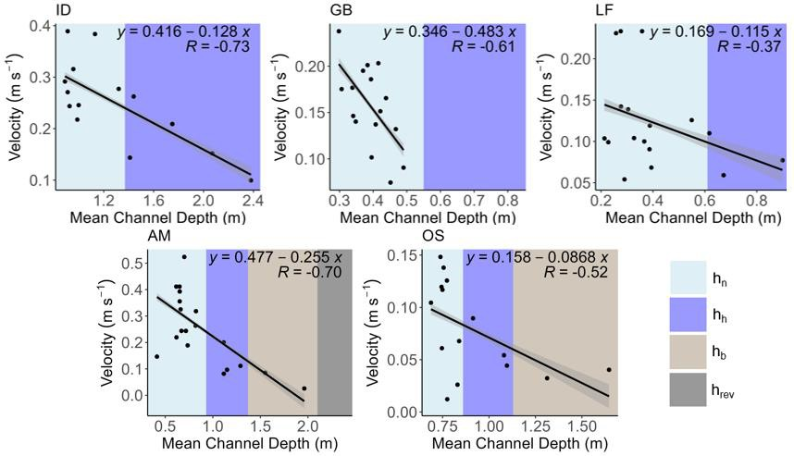

*Figure 3: Field measured velocity (m s-1) is negatively correlated with stage (m) across all sites. Light blue represents undisturbed periods (hnorm), purple represent high stage events (hhigh), brown represents brownouts (hbrown), and gray represents flow reversals (hreversals). The response between velocity and stage varied among the sites. For example, velocity in OS responds far less to stage variation than at AM.*

Temporal variation in stage and velocity impact the gas exchange rates, which I both estimated and measured. Overall, gas dome measurements were more conservative than the Raymond et al. (2012), John et al. (2006), and Knight (1980) models with slightly lower values, and less sensitivity to stage and velocity variation but lies within the various estimates. As expected, *k600* increased with decreasing stage, which is when velocity increases, and was lowest during river reversal (RR). GB experienced the largest range in *k600*, ranging from an extremely low 1 day-1 during the single flood observed on that river (hhigh) and reaching 20 day-1 at low stage (hnorm).

I observed strong correspondence between the various models and measured values (Fig. 3-2), with measured values (black points and lines)) generally within the range of the various model estimates (gray lines and dots). The final selected *k600* curves based on interpolated velocity and stage (red lines) are exactly aligned with dome measurements, except for at OS where the dome data at the end of the spring run strongly disagreed with one-station estimates of k600 from the entire reach, and I adopted the latter.

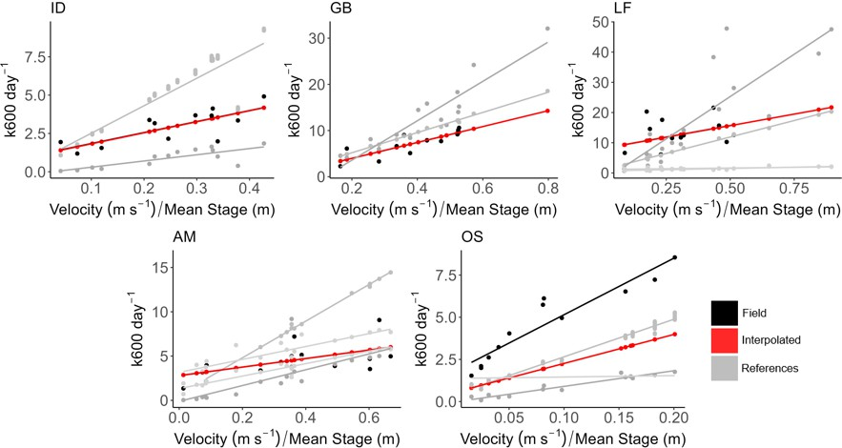

*Figure 4. Rating curves to estimate k600 from river channel hydraulic variation (velocity and depth). The red line represents the rating curve I applied to obtain metabolism estimates. Gray lines represent various k600 models from Raymond et al. (2012), Johns et al. (2006), and Knight (1980). Black points and lines are field measurements; for all sites except OS, red and black lines are identical.*

**Chemical Time Series with Flood Events:**

The sensors for the main solutes of interest (DO, CO2, FDOM, pH, and SpC) all recorded data during one high stage event (hhigh) at each site despite significant deployment challenges. These resulting time series allow me to investigate chemical responses to fluctuating stage in each spring but not necessarily how the chemical responses vary with differing disturbance magnitudes. The time series of solutes varied distinctly and predictably with fluctuating stage. DO and CO2 were strongly inversely coupled, both at the daily scale (diurnal variation) and over longer timescales (Figure 3-4). During every backwater-induced flood, both brownouts (hbrown) or reversals (hreversal), hypoxic conditions (DO < 2 mg/L) prevailed for some duration (11-24 days) (21-46% of the disturbance), and CO2 reached its maximum.

Other solutes that trace the change in source water, including FDOM, pH, and SpC, remained unchanged during low severity hhigh but were clearly altered during hbrown and hreversal events (Figure 3-3). The shift towards river water resulted in more acidic pH and greater FDOM concentrations. I observed a strong decreasing shift in conductivity during hreversal, indicating the replacement of aquifer water in the spring- run with Suwannee River water. However, during hbrown, SpC was only modestly changed which may arise as waters of different density result in a poorly mixed water column from which sensor deployed near the benthic surface sampled only the denser aquifer water.

During modest floods, the rise in stage and decline in velocity leads to declines in both the mean DO and the diurnal amplitude (Fig. 3-4, High Stage Events), a pattern that is inversely matched by the dynamics of CO2. At more significant floods (e.g., the brownout shown in Fig. 3-4, Brownout), the diurnal DO amplitude is eliminated, indicating the loss of primary production, and a prolonged period of hypoxia occurred (~20 days). Notably, the most extreme floods yielded a different pattern. AM experienced a reversal during which tannic river water was observed displacing aquifer water, (Fig. 3-4, Flow Reversal) with negative flow velocities (-0.005 m s-1) and associated declines in specific conductance (data not shown). During the height of this reversal, spring oxygen levels spiked, signifying the entry of river water with higher average DO than spring water. I note that while OS also experienced a RR this 02/2022 flood, DO did not spike-and-fall there indicating that OS only experienced a brownout (hbrown). The relative impact of true reversals (hreversal) vs. hbrown remains unclear, but I note that while reversals are hypothesized to be a more ecologically harmful since they usually last longer and completely shift the water source in the spring-run, the persistence of hypoxia was far longer during the brownout, which may have especially important detrimental consequences for ecosystem function (Hensley et al., 2019; Hensley & Cohen, 2017, Donsky 2023).

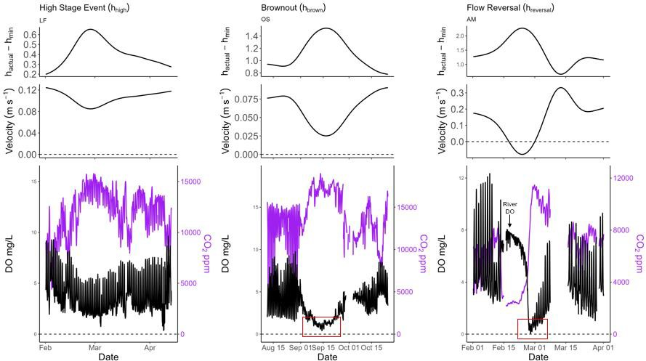

*Figure 5: Time series of DO (black) and CO2 (purple) through high-stage events of varying severity. In all cases, as stage rises, DO amplitude decreases, DO levels decrease and CO2 concentrations increase implying strong coupling. At the peak of a flow reversal in AM (right panel), DO spikes and CO2 declines as river water completely displaces aquifer water in the spring-run. Hypoxic conditions (DO < 2 mg L-1) (red squares) that persist during brownouts, and after reversals are of ecological significance.*

**Metabolic Responses to Flood Events:**

Overall, including normal (hnorm) and high (hhigh) stage, sites were heterotrophic with a GPP ~ 5 g O2 m-2 d-1 and an ER ~ −12 g O2 m-2 d-1 (IU, ID, AM, and OS) (Figure 3-5). LF had the greatest variation despite no river water influence. IU, the chemostatic spring-run, had the least variability in its metabolic regime, remaining near a GPP ~ 5 g O2 m-2 d-1 with fluctuating stage.

Regardless of blackwater influence, GPP had a significant, negative relationship with Δh (p- value< 0.001), and ER had a significant positive relationship with Δh (p-value< 0.001) (Fig. 3-5), indicating NEP consistently declines with increasing stage. However, the rate and extent in which each metabolic signal changed varied among the sites without obvious pattern. For instance, GB and ID both rarely experience floods and have similar GPPs and ERs (5.1 ± 3.3 g O2 m-2 d-1, and -11.6 ± 4.6 g O2 m-2 d-1 for ID; and 7.1 ± 3.9 g O2 m-2 d-1 and -12.2 ± 6.9 g O2 m-2 d-1 for GB) yet ID’s NEP slope is -13.3 g O2 m-3 d-1 while GB is a massive -52.5 g O2 m-3 d-1. None the less, these strong correlations between Δh and spring metabolism have important implications for future spring metabolic inferences, allowing these Δh-NEP, Δh-GPP, and Δh-ER relationships to estimate future observations. As mentioned, each springs relationship with Δh varied without obvious pattern indicating a site-specific rating curve must be conducted across varying stage conditions requiring energy intensive research at the forefront but allows spring-run NEP to be estimated for the entirety of public record (+5 years).

*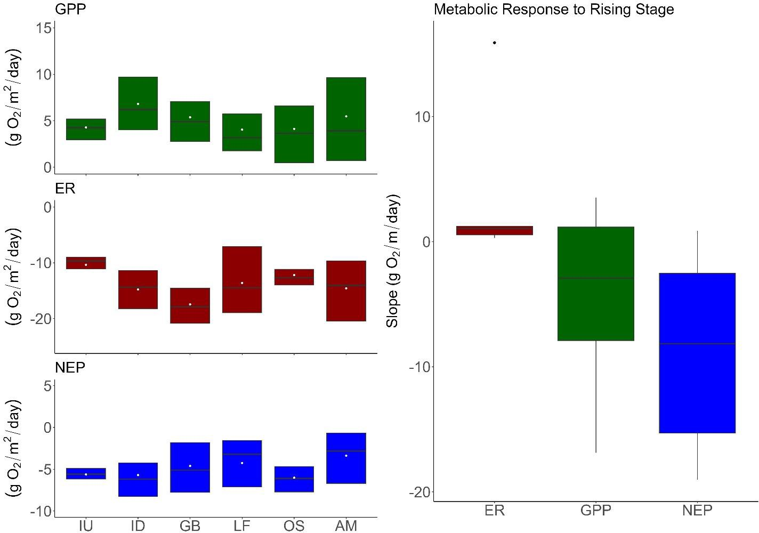Figure 6: Site-specific patterns of GPP (green), ER (red), NEP (blue) in response to changing stage (Δh) (reported here as departure from minimum stage). Overall, GPP decreased, and ER increased with increasing stage, resulting in consistent declines in NEP with decreasing velocity.*

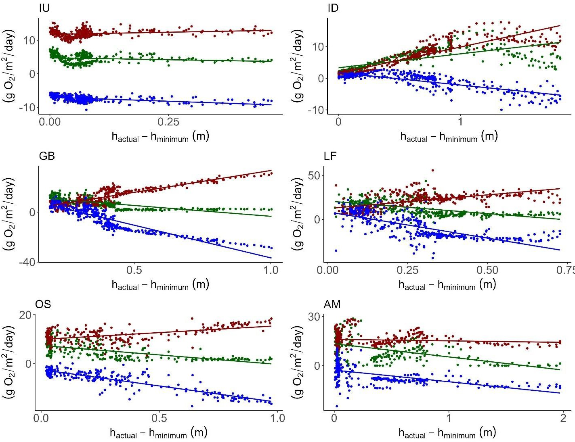

*Figure 6 continued: Site-specific patterns of GPP (green), ER (red), NEP (blue) in response to changing stage (Δh) (reported here as departure from minimum stage). Overall, GPP decreased, and ER increased with increasing stage, resulting in consistent declines in NEP with decreasing velocity.*

**GPP and ER Reduction During Floods:**

GPP and ER decreased during floods (GPP mean= 76%; ER mean= 43%) however only GPP’s relationship with Δh was significant, decreasing with increasing Δh (Figure 3-8). My hypothesis that disturbance magnitude will be reflected in spring-runs’ metabolic response with GPP and ER decreasing with increasing disturbance magnitude is partly correct. During each river reversal, whether a brownout (hbrown) or a flow reversal (hreversal), GPP was diminished to 0. As for high stage events (hhigh), GPP declined with increasing stage. ER increased with increasing stage regardless of river influence (Figure 3-8). RR frequency had negative trend with ER (p=0.136), with sites experiencing less frequent disturbance experiencing a greater increase in ER. GPP response to disturbance displayed no trend with disturbance regime (Figure 3-9).

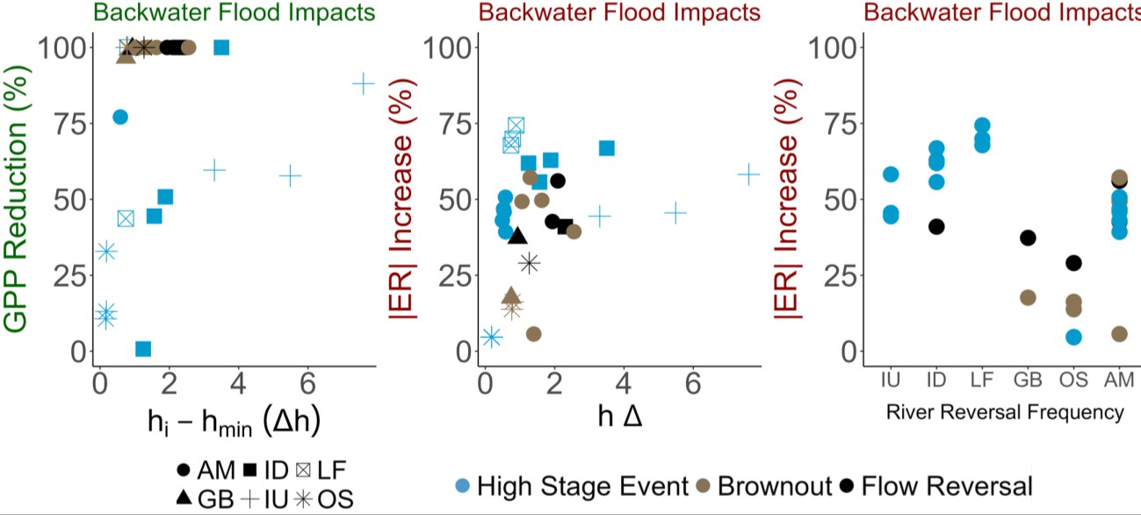

*Figure 7. Proportional metabolic responses (i.e., reduction in GPP (green) and ER (red) compared with normal flow conditions) as a function of the magnitude of discrete flood events, measured as the maximum stage increase. In all cases, GPP and ER decreased during the floods. GPP declined to zero but had negative relationship with stage during high stage events. ER had a positive relationship with stage, regardless of river influence, and sites with more severe disturbance regimes tended to have less ER increases.*

**Flood Recovery:**

To determine whether disturbance magnitude influenced spring recovery, I estimated the time for GPP, ER, and stage to recover to pre-flood conditions following a flood event. The recovery ratio (Recoverystage / Recoverymetabolic) has values >1 when metabolism recovers faster than stage, and values <1 when metabolism recovers more slowly. At most springs and disturbances, GPP and ER recovered slightly faster (~5 days) than stage (mean recovery ratio across all springs and events = 1.12 for GPP and 1.08 for ER) indicating spring-run metabolic functions are resilient to flood events regardless of river influence or flood severity (Figure 3-10). Overall, ER recovered more quickly than GPP likely due to comparatively smaller reductions in ER and the rate at which heterotrophic microbial communities can re-initiate their remineralization of stored OM, particularly since scour and removal of that stored OM is not a feature of floods in these rivers (Figure 3-6).

These results provide no support for the hypothesis that increasing disturbance magnitude will result in longer metabolic recoveries. The absence of a clear pattern between disturbance magnitude and recovery, and indeed the idea that metabolic recovery is, on average, faster than stage suggests that spring metabolic function is surprisingly resilient to these floods. However, sites with more severe disturbance regimes tended to recover their metabolic regime faster than less disturbed sites (p=0.95) (Figure 3-11). Excluding ID’s flow reversal, an extremely rare occurrence for this site, and its subsequent high stage event, ER recovery correlation with disturbance frequency strengthens but is still insignificant (p=0.92).

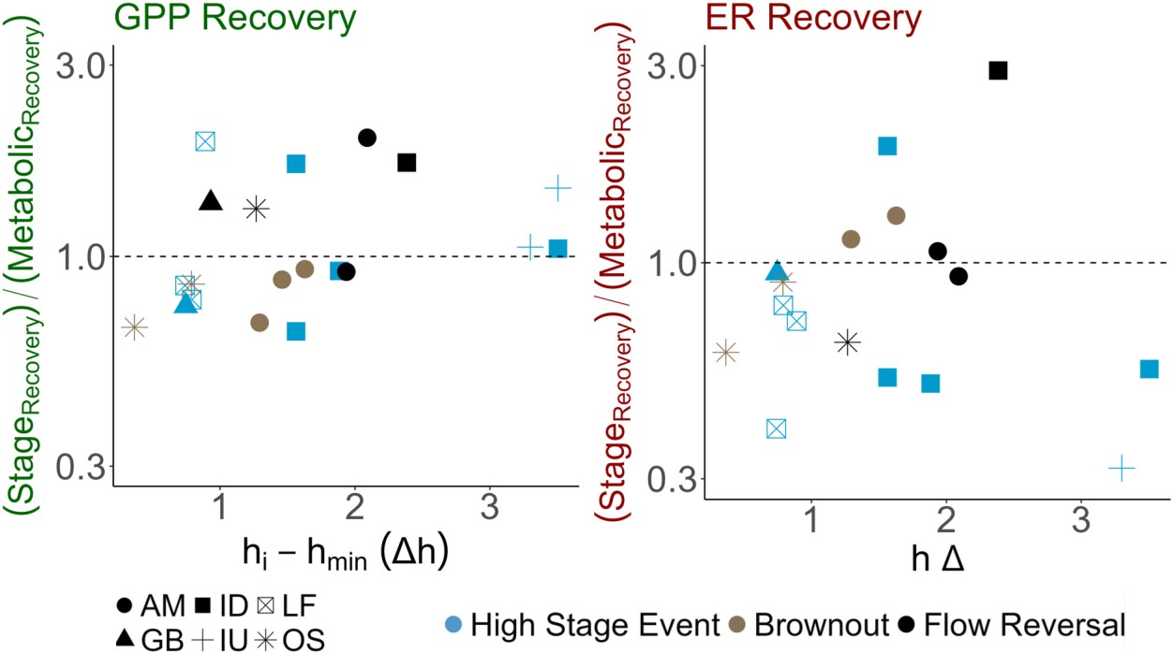

*Figure 9: GPP (green) and ER (red) recover more quickly than hydrological recession following floods. Both plots show the relationship between flood disturbance severity and the time for GPP and ER to recover to pre-disturbance levels, indexed to the time for flood recession recovery. At left, flood disturbance is measured as a function of peak stage, and in the middle, RR frequency gradient in ascending order. The plot on the right displays the distribution of recovery. There was not a significant relationship between spring-run recovery and disturbance magnitude nor its disturbance regime, suggesting spring-runs are highly resilient to flood disturbances.*

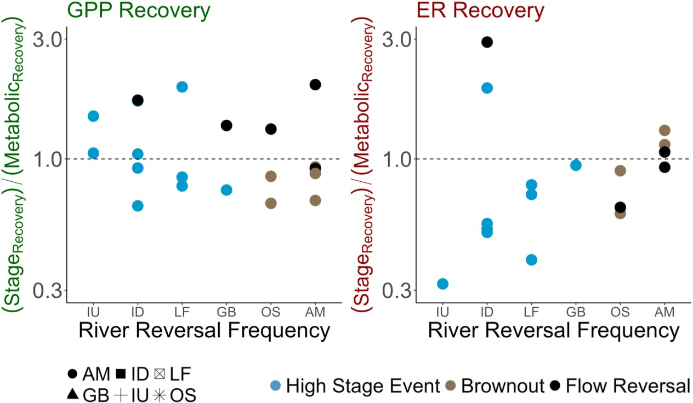

*Figure 10: GPP (green) and ER (red) recover more quickly than hydrological recession following floods. Both plots show the relationship between disturbance regime and the time for GPP and ER to recover to pre-disturbance levels, indexed to the time for flood recession recovery. GPP recovery displayed no relationship with disturbance regime. ER tended to recover more quickly in more frequently disturbed but this trend was insignificant (p=0.95).*

**Stability:**

Among sites, GPP and ER displayed autocorrelations between approximately 0.9 and 0.6 for AR1, and around 0.85 to 0.2 for AR10. As anticipated, the autocorrelation between GPP and ER was most pronounced at AR1 and significantly decreased with AR10. Notably, this autocorrelation pattern closely mirrored the RR frequency gradient. IU, ID, and GB exhibited the highest autocorrelation, followed by LF, OS, and AM. In comparison to the dataset in Appling et al., (2018), these spring-runs generally displayed greater autocorrelation in GPP and ER, suggesting that spring-run metabolic regimes are comparatively more stable than those in typical flowing waters. It's worth noting that, unlike Appling et al. (2018), the decline in autocorrelation for GPP and ER over time in spring-runs was relatively small.

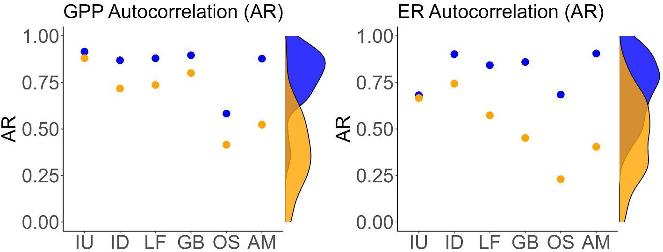

*Figure 11. Temporal autocorrelation (1 day lag, AR1 and 10-day lag, AR10) for each of the sites, sorted along the x-axis in order of increasing flood risk. Rarely disturbed springs had greater metabolic stability (higher AR1 and AR10 for both ER and GPP) than frequently disturbed springs. For reference, the AR1 and AR10 of sites in the Appling et al. (2018) synthesis of metabolism across the US are shown (density plots).*

**Discussion:**

**High Stage Events Consistently Impact Spring-Run Metabolism:**

As both stage and disturbance magnitude increased, I observed decreases in GPP and increases in ER, resulting in a significant decrease of NEP (Figure 3-5). Additionally, rising stage led to a significant increase in CO2 concentrations while DO concentrations significantly decreased (Figure 3-4). These flood impacts were consistent across all sites, including high-stage events (hhigh), which also exhibited significant effects. However, it's important to note that each site showed varying sensitivity to flood disturbances.

In spring-runs, floods are a consequence of downstream backwater effects that elevate stage and significantly reduce flow. This alteration in flow dynamics results in reduced water clarity, primarily through increased OM inputs (Brown et al., 2014; Hensley & Cohen, 2017), and/or increased stage that hinders light penetration through the deeper water column (Hosen et al., 2019; Julian et al., 2008). In contrast, floods in streams also increase stage (like spring-runs), but induce bed scouring flow (LeRoy Poff et al., 1997). Unlike high flow in spring-runs, bed scour disturbs the benthic environment, increasing stream turbidity and removing organic matter and biomass from the channel, either exporting it out of the watershed or redepositing it downstream (Bernhardt et al., 2018; Hosen et al., 2019; LeRoy Poff et al., 1997; Uehlinger, 2000). Spring-run biomass is also affected by backwater floods (Albertin & Stevenson, 2007; Stevenson et al., 2004), however not to the extent of bed scour impacts. The absence of bed scour is a unique characteristic of spring-runs. In these environments where seasonal variations are relatively modest (Fernald & Purdum, 1998), and nutrients remain consistently available (Brown et al., 2014), this emphasizes the significance of clarity and stage as a primary determinant of spring-run productivity.

During the study period, I observed that DO concentrations fluctuated in tandem with stage variations, offering preliminary evidence that spring-run metabolism could be inferred with stage (Figure 3-4). However, it's important to note that evaluating spring-run GPP, ER, and NEP with stage would necessitate a site-specific evaluation of spring-run sensitivity to fluctuating stage across various spring-run disturbances. Each of the study sites exhibited a unique relationship between stage and metabolism (Figure 3-5), likely influenced by site-specific geomorphic and hydrological conditions, as well as specific light constraints associated with seasonality and canopy cover. For instance, sites with similar average stage (such as IU and ID), sites with comparable velocities (like GB and OS), and sites near each other (e.g., OS and LF) all displayed significantly different relationships between their stage and metabolism. Due to below-average precipitation during the study period, I was unable to capture the full spectrum of disturbance events that these spring-runs could potentially experience. This limitation prevented me from interpolating ER and GPP data for all available records across sites. While further research is needed, this study clearly underscores the role of clarity and stage as a determinant of spring-run metabolic regimes. Moreover, it provides initial evidence of stage as a valuable tool for understanding historical spring-run metabolism.

**Brownouts are More Ecologically Significant than Flow Reversals:**

Both types of RRs induced hypoxic conditions that persisted for 11 to 24 days, providing further evidence that light is the primary determining factor in spring-run metabolism. Once light availability is diminished, the increased inflow of river water has no additional influence on GPP. This suggests that both hreversal and hbrown create similar metabolic impacts.

Consequently, hbrown, which occurred 2-3 times during the study period, are likely more ecologically significant due to their higher frequency, as they shade the spring-run with every event, potentially having a more profound impact on the ecosystem.

In addition to the systematic changes in metabolism associated with backwater floods, the magnitude of disturbance had a notable and consequential impact on GPP. GPP exhibited a significant negative trend with increasing flood stage, decreasing as disturbance magnitude increased (Figure 3-8). Notably, one exception to this trend was IU, representing a chemostatic spring-run, where GPP remained relatively stable due to minimal stage and clarity changes between normal periods (hnorm) and high-stage events (hhigh). The observed reductions in GPP during disturbances in spring-runs surpassed productivity losses seen in alpine floods and forested streams (Roberts & Mulholland, 2007; Uehlinger, 2000) and were consistent with GPP reductions observed in urban streams (Reisinger et al., 2017),

In contrast, there was no discernible effect of disturbance magnitude on ER, suggesting that, while overall respiration increased during all floods, larger floods did not necessarily result in proportionally larger inputs frequently emerge as primary controls of ER, both having positive relationships, but the response varies depending on the ecosystem (Acuña et al., 2004; Fuss & Smock, 1996; Meyer & Edwards, 1990; Mulholland et al., 2001; Shen et al., 2015; Sinsabaugh, 1997). FDOM significantly increased between hhigh and brownouts (hbrown) (Figure 3-3), yet hhigh experienced ER increases like those observed during hbrown. Flow reversals (hreversal) showed a slight decrease in FDOM, but due to the limited data available (approximately 7 days of hreversal), drawing conclusions about hreversal impacts on ER remains challenging. Temperature, which influences the rate of respiration, did not significantly change with increasing disturbance magnitude, however, its impact on ER is not universally consistent across the literature (Acuña et al., 2004; Bernhardt et al., 2018; Meyer & Edwards, 1990; Sinsabaugh, 1997). Another possibility for the observed ER trend may be related to DO becoming more limiting with increasing disturbance magnitude, hindering both GPP and ER and shifting spring-runs towards anaerobic reactions. The increase in FDOM during hhigh may have stimulated greater ER, while hypoxia during hbrown may have limited respiration, contributing to the lack of a significant trend in ER.

**Light as a Determinant of Disturbance Magnitude, While Bed Scour Shapes Lotic Resilience:**

The post-flood recovery of spring-runs provides evidence that while light may influence the response in GPP and ER, the primary determinant of lotic resilience is bed scour. Commonalities between RRs and typical stream floods include channel shading, increased depths, and the introduction of organic nutrients. As mentioned, in streams, bed-scouring flows disturb the benthos, increase stream turbidity, and export biomass effects on ER (Figure 3-8). On average, ER increased 63% during floods, whether a river reversal (RR) or hhigh. The reasons for the seemingly random yet positive ER reaction with disturbance magnitude is largely speculative. ER constraints are less clear than GPP constraints. Temperature and OM from the channel, potentially even from the watershed entirely (Hensley et al., 2019; LeRoy Poff et al., 1997). Consequently, both RRs and stream floods drive flowing waters toward hypoxia (Martí et al., 1997), with a notable difference being the absence of bed scour in RRs.

In this study, I observed that backwater floods do not significantly impact spring recovery.

Following nearly every flood event, GPP and ER rebounded faster than stage, indicating high resilience of spring-run metabolism (Figure 3-9). The exception was OS, characterized by slower flow, lacking the force to flush river water from the spring-run post-flood, which allowed metabolic impacts to persist. In contrast, streams affected by floods may require up to a decade for vegetation and taxa to recover (Woodward et al., 2015), particularly when these floods occur in close succession, potentially altering ecosystem function over time (Baker & Walford, 1995; Uehlinger, 2000). While disturbance is recognized as a fundamental aspect of flowing metabolic regimes, defining characteristics of a lotic disturbance regime remain poorly understood. Light, like stream metabolism, influences disturbance magnitude, but resilience and function are primarily governed by bed scour, involving the extensive removal of channel biomass. This suggests that spring-run productivity is not solely attributed to their chemostatic nature but also to the absence of scouring floods.

**Disturbance as a Key Driver of Spring-run Metabolic Regimes and Typology:**

Frequently disturbed springs exhibited higher metabolic variability compared to rarely disturbed springs, emphasizing the fundamental role of disturbance in shaping ecosystem function, especially in systems where disturbances have traditionally received less attention (Figure 3-10). These findings display the significant distinctions between frequently disturbed and rarely disturbed springs.

Frequently disturbed springs tend to be located near their receiving blackwater rivers, whereas rarely disturbed springs feature longer runs that are more distant from downstream rivers. This aligns with the overarching hypothesis that Florida Springs' "chemostatic" archetype may apply to springs distant from rivers but not to those in proximity. This research suggests that spring flood disturbances play a defining role in the metabolic regimes of these systems. Disturbance has emerged as a key factor in lotic metabolic regimes in general, and results suggest springs are no exception. Furthermore, this research underscores the importance of considering spring ecosystems as spanning a gradient of natural flow regimes that include the large chemostatic springs that never flood, which represent the archetypal

metabolic regime often adopted for Florida’s springs, but also those springs that are subject to prolonged and highly consequential flooding that dramatically impact metabolism. Only by accurately establishing the expected metabolic regime can we hope to manage and restore the ecosystem functions of our precious springs.

**Challenges and Implications:**

**Navigating Challenges in Modeling North Florida's Spring-Run Metabolism:**

Along with technical challenges, modeling North Florida's spring-runs presented unique obstacles. One prominent challenge was the inadequacy of the two-station metabolism method in representing boundary conditions, particularly in porous, karst flowing waters where locating suitable headwaters for an upstream station could be quite challenging. This challenge became evident at AM and LF, where I had to search for the correct vents to serve as the upstream station. In the case of AM, I encountered three vents, while at LF, I found two vents before finally settling on vents closer to sensor deployments. Conversely, for GB and Ichetucknee (IU and ID), the headspring was readily identifiable.

Additionally, it's important to note a limitation of the one-station metabolism model, *streamMetabolizer*, which may have led to overestimations of GPP and ER during flow reversals (hreversal). *StreamMetabolizer* interprets any increase in DO as a sign of increased productivity. While this interpretation is generally valid for typical stream disturbances, during hreversal, intruding river water with higher DO levels can raise DO concentrations within the reversed spring-run. Consequently, *StreamMetabolizer* misinterprets this DO spike as a productivity increase rather than an introduction of a new end member. Data collection during hreversal was limited to approximately seven days. Therefore, the extent to which *StreamMetabolizer* overestimated GPP and ER remains unclear. Nevertheless, based on direct observations of the hreversal at AM, where stage reached its maximum and the spring-run exhibited blackwater conditions, it is highly unlikely that primary producers were actively photosynthesizing, and the observed increases in DO were primarily attributed to the intruding river water.

Lastly, it's worth noting that the study took place during a period of atypically dry conditions in the Suwannee and Santa Fe Basin, resulting in only one hreversal being observed. While this research clearly demonstrates the ecological significance of brownouts (hbrown) compared to hreversal, capturing hreversal conditions at sites like GB and OS would provide a more comprehensive understanding of spring- run disturbances. Nonetheless, findings offer valuable insights into the metabolic implications of river reversals (RRs).

**Future Implications in Metabolism Modeling for North Florida Spring-Runs:**

Throughout the study, I employed both two-station and one-station metabolism methods to model spring-run metabolism, depending on the prevailing conditions. The transition between these methods posed certain challenges. During normal flow and flood conditions (hnorm), I felt confident in the estimation of GPP, ER and NEP. However, during the transitional period (hhigh < transitional period > hnorm), where stage fluctuated and chemical responses were notable, there may be some uncertainty in the accuracy of the models. This transitional phase warrants further investigation to better understand its dynamics.

Moreover, for hreversal, where the upstream boundary shifts from the spring vent to the receiving river, complications arise when using the two-station methods. The source waters essentially reverse and DO concentrations in the river typically exceed those in the now "downstream" spring-run, potentially resulting in unrealistic ER rates. For the one observed hreversal, the flow velocity violated the *0.4u k-1 > L* threshold, requiring one-station methods. Furthermore, considering the locations of the study sites at the confluence of the spring-run with the downstream river, the use of one-station methods was deemed sufficient. However, it's important to acknowledge that for sites like IU, where metabolism is modeled closer to the spring vent, hreversal events may present unique challenges that require in-depth investigation and tailored methodologies.

LIST OF REFERENCES

Acuña, V., Giorgi, A., Muñoz, I., Uehlinger, U., & Sabater, S. (2004). Flow extremes and benthic organic matter shape the metabolism of a headwater Mediterranean stream. *Freshwater Biology*, *49*(7), 960–971. https://doi.org/10.1111/j.1365-2427.2004.01239.x

Albertin, A., & Stevenson, R. J. (2007). Estimation of Autochthonous Sources of C, N, and P in Florida Springs. https://[www.researchgate.net/publication/242605073.](http://www.researchgate.net/publication/242605073)

Appling, A. P., Hall, R. O., Yackulic, C. B., & Arroita, M. (2018). Overcoming Equifinality: Leveraging Long Time Series for Stream Metabolism Estimation. *Journal of Geophysical Research: Biogeosciences*, *123*(2), 624– 645. https://doi.org/10.1002/2017JG004140

Appling, A. P., Read, J. S., Winslow, L. A., Arroita, M., Bernhardt, E. S., Griffiths, N. A., Hall, R. O., Harvey, J. W., Heffernan, J. B., Stanley, E. H., Stets, E. G., & Yackulic, C. B. (2018). Data descriptor: The metabolic regimes of 356 rivers in the United States. *Scientific Data*, *5*. https://doi.org/10.1038/sdata.2018.292

Odum, H. T. (1957). Trophic structure and productivity of Silver Springs, Florida. *Ecological monographs*, *27*(1), 55-112.

Baker, W. L., & Walford, G. M. (1995). Multiple stable states and models of riparian vegetation succession on the Animas River, Colorado. *Annals of the Association of American Geographers, 85*(2), 320-338.

Bernal, S., Cohen, M. J., Ledesma, J. L. J., Kirk, L., Martí, E., & Lupon, A. (2022). Stream metabolism sources a large fraction of carbon dioxide to the atmosphere in two hydrologically contrasting headwater streams. *Limnology and Oceanography*, *67*(12), 2621–2634. https://doi.org/10.1002/lno.12226

Bernhardt, E. S., Heffernan, J. B., Grimm, N. B., Stanley, E. H., Harvey, J. W., Arroita, M., Appling, A. P., Cohen, M. J., McDowell, W. H., Hall, R. O., Read, J. S., Roberts, B. J., Stets, E. G., & Yackulic, C. B. (2018). The metabolic regimes of flowing waters. In *Limnology and Oceanography* (Vol. 63, pp. S99–S118). Wiley Blackwell. https://doi.org/10.1002/lno.10726

Bernhardt, E. S., Savoy, P., Vlah, M. J., Appling, A. P., Koenig, L. E., Hall, R. O. E., Arroita, M., Blaszczak, J. R., Carter, A. M., Cohen, M., Harvey, J. W., Heffernan, J. B., Helton, A. M., Hosen, J. D., Kirk, L., Mcdowell, W. H., Stanley, E. H., Yackulic, C. B., & Grimm, N. B. (2019). *Light and flow regimes regulate the metabolism of rivers*. https://doi.org/10.1073/pnas.2121976119/-/DCSupplemental

Bertuzzo, E., Hotchkiss, E. R., Argerich, A., Kominoski, J. S., Oviedo-Vargas, D., Savoy, P., Scarlett, R., von Schiller, D., & Heffernan, J. B. (2022). Respiration regimes in rivers: Partitioning source-specific respiration from metabolism time series. *Limnology and Oceanography*, *67*(11), 2374–2388. https://doi.org/10.1002/lno.12207

Brown, A. L., Martin, J. B., Screaton, E. J., Ezell, J. E., Spellman, P., & Gulley, J. (2014). Bank storage in karst aquifers: The impact of temporary intrusion of river water on carbonate dissolution and trace metal mobility. *Chemical Geology*, *385*, 56–69. <https://doi.org/10.1016/j.chemgeo.2014.06.015>

Copeland, B. J., & Duffer, W. R. (1964). Use of a Clear Plastic Dome to Measure Gaseous Diffusion Rates in Natural Waters. *Limnology and Oceanography*, *9*(4), 494–499. https://doi.org/10.4319/lo.1964.9.4.0494

Demars, B. O. L., Thompson, J., & Manson, J. R. (2015). Stream metabolism and the open diel oxygen method: Principles, practice, and perspectives. *Limnology and Oceanography: Methods*, *13*(7), 356–374. https://doi.org/10.1002/lom3.10030

Duarte, C. M., Prairie, Y. T., Frazer, T. K., Hoyer, M. v., Notestein, S. K., Martínez, R., Dorsett, A., & Canfield, D. E. (2010). Rapid accretion of dissolved organic carbon in the springs of Florida: The most organic-poor natural waters. *Biogeosciences*, *7*(12), 4051–4057. https://doi.org/10.5194/bg-7-4051-2010

Fernald, E. A., & Purdum, E. D. (1998). Water Resources Atlas of Florida. Florida State University. *Library of Congress Catalog*, 38–63.

Fuss, C. L., & Smock, L. A. (1996). Spatial and temporal variation of microbial respiration rates in a blackwater stream. *Freshwater Biology*, *36*(2), 339–349. https://doi.org/10.1046/j.1365-2427.1996.00095.x

Gulley, J. D., Martin, J. B., Spellman, P., Moore, P. J., & Screaton, E. J. (2014). Influence of partial confinement and Holocene River formation on groundwater flow and dissolution in the Florida carbonate platform. *Hydrological Processes*, *28*(3), 705–717. https://doi.org/10.1002/hyp.9601

Gulley, J., Martin, J. B., Screaton, E., & Moore, P. J. (2011). River reversals into karst springs: A model for cave enlargement in eogenetic karst aquifers. *Bulletin of the Geological Society of America*, *123*(3–4), 457–467. <https://doi.org/10.1130/B30254.1>

Hall, R. O., & Ulseth, A. J. (2020). Gas exchange in streams and rivers. In *Wiley Interdisciplinary Reviews: Water* (Vol. 7, Issue 1). John Wiley and Sons Inc. https://doi.org/10.1002/WAT2.1391

Hall, R. O., Yackulic, C. B., Kennedy, T. A., Yard, M. D., Rosi-Marshall, E. J., Voichick, N., & Behn, K. E. (2015). Turbidity, light, temperature, and hydropeaking control primary productivity in the Colorado River, Grand Canyon. *Limnology and Oceanography*, *60*(2), 512–526. https://doi.org/10.1002/lno.10031

Heffernan, J. B. (2008). Wetlands as an alternative stable state in desert streams. *Ecology*, *89*(5), 1261–1271. https://doi.org/10.1890/07-0915.1

Hensley, R. T., & Cohen, M. J. (2017). Flow reversals as a driver of ecosystem transition in Florida’s springs. *Freshwater Science*, *36*(1), 14–25. https://doi.org/10.1086/690558

Hensley, R. T., Cohen, M. J., & Korhnak, L. V. (2015). Hydraulic effects on nitrogen removal in a tidal spring-fed river. *Water Resources Research*, *51*(3), 1443–1456. https://doi.org/10.1002/2014WR016178

Hensley, R. T., Kirk, L., Spangler, M., Gooseff, M. N., & Cohen, M. J. (2019). Flow Extremes as Spatiotemporal Control Points on River Solute Fluxes and Metabolism. *Journal of Geophysical Research: Biogeosciences*, *124*(3), 537–555. <https://doi.org/10.1029/2018JG004738>

Hosen, J. D., Aho, K. S., Appling, A. P., Creech, E. C., Fair, J. H., Hall, R. O., Kyzivat, E. D., Lowenthal, R. S., Matt, S., Morrison, J., Saiers, J. E., Shanley, J. B., Weber, L. C., Yoon, B., & Raymond, P. A. (2019). Enhancement of primary production during drought in a temperate watershed is greater in larger rivers than headwater streams. *Limnology and Oceanography*, *64*(4), 1458–1472. https://doi.org/10.1002/lno.11127

Jawitz, J. W., & Mitchell, J. (2011). Temporal inequality in catchment discharge and solute export. *Water Resources Research*, *47*(10). https://doi.org/10.1029/2010WR010197

Julian, J. P., Doyle, M. W., & Stanley, E. H. (2008). Empirical modeling of light availability in rivers. *Journal of Geophysical Research: Biogeosciences*, *113*(3). https://doi.org/10.1029/2007JG000601

Khadka, M. B., Martin, J. B., & Jin, J. (2014). Transport of dissolved carbon and CO2 degassing from a river system in a mixed silicate and carbonate catchment. *Journal of Hydrology*, *513*, 391–402. https://doi.org/10.1016/j.jhydrol.2014.03.070

King, S. A. (2014). Hydrodynamic control of filamentous macroalgae in a sub-tropical spring-fed river in Florida, USA. *Hydrobiologia*, *734*(1), 27–37. https://doi.org/10.1007/s10750-014-1860-2

Kirk, L. (2020). Metabolism in Subtropical Lowland Rivers.

Kirk, L., Hensley, R. T., Savoy, P., Heffernan, J. B., & Cohen, M. J. (2021). Estimating Benthic Light Regimes Improves Predictions of Primary Production and constrains Light-Use Efficiency in Streams and Rivers. *Ecosystems*, *24*(4), 825–839. https://doi.org/10.1007/s10021-020-00552-1

LeRoy, N., J. David Allan, M. B. Bain, J. R. Karr, K. L. Prestegaard, B. D. Richter, R. E. Sparks, and J. C. Stromberg. "The natural flow regime." *BioScience* 47, no. 11 (1997): 769-784.

Martí, E., Grimm, N. B., & Fisher, S. G. (1997). Pre-and post-flood retention efficiency of nitrogen in a Sonoran Desert stream*. Journal of the North American Benthological Society, 16*(4), 805-819.

McDowell, M. J., & Johnson, M. S. (2018). Gas Transfer Velocities Evaluated Using Carbon Dioxide as a Tracer Show High Streamflow to Be a Major Driver of Total CO2 Evasion Flux for a Headwater Stream. *Journal of Geophysical Research: Biogeosciences*, *123*(7), 2183–2197. https://doi.org/10.1029/2018JG004388

Meyer, J. L., & Edwards, R. T. (1990). Ecosystem metabolism and turnover of organic carbon along a blackwater river continuum. *Ecology*, 71(2), 668-677.

Mulholland, P. J., Fellows, C. S., Tank, J. L., Grimm, N. B., Webster, J. R., Hamilton, S. K., Martí, E., Ashkenas, L., Bowden, W. B., Dodds, W. K., Mcdowell, W. H., Paul, M. J., & Peterson, B. J. (2001). Inter-biome comparison of factors controlling stream metabolism. *Freshwater Biology*, *46*(11), 1503–1517. https://doi.org/10.1046/j.1365-2427.2001.00773.x

Odum, H. T. (1956). Primary Production in Flowing Waters. *Limnology and Oceanography*, *1*(2), 102–117. <https://doi.org/10.4319/lo.1956.1.2.0102>

Reichert, P., Uehlinger, U., & Acuña, V. (2009). Estimating stream metabolism from oxygen concentrations: Effect of spatial heterogeneity. *Journal of Geophysical Research: Biogeosciences*, *114*(3). https://doi.org/10.1029/2008JG000917

Reisinger, A. J., Rosi, E. J., Bechtold, H. A., Doody, T. R., Kaushal, S. S., & Groffman, P. M. (2017). Recovery and resilience of urban stream metabolism following Superstorm Sandy and other floods. *Ecosphere*, *8*(4). https://doi.org/10.1002/ecs2.1776

Riley, A. J., & Dodds, W. K. (2013). Whole-stream metabolism: Strategies for measuring and modeling diel trends of dissolved oxygen. *Freshwater Science*, *32*(1), 56–69. https://doi.org/10.1899/12-058.1

Roberts, B. J., & Mulholland, P. J. (2007). In-stream biotic control on nutrient biogeochemistry in a forested stream, West Fork of Walker Branch. *Journal of Geophysical Research: Biogeosciences*, *112*(4). https://doi.org/10.1029/2007JG000422

Shen, X., Sun, T., Liu, F., Xu, J., & Pang, A. (2015). Aquatic metabolism response to the hydrologic alteration in the Yellow River estuary, China. *Journal of Hydrology*, *525*, 42–54. https://doi.org/10.1016/j.jhydrol.2015.03.013

Sinsabaugh, R. L. (1997). Large-Scale Trends for Stream Benthic Respiration. In *Source: Journal of the North American Benthological Society* (Vol. 16, Issue 1). https://about.jstor.org/terms

Stevenson, R. J., Pinowska, A., & Wang, Y. K. (2004). *Ecological condition of algae and nutrients in Florida springs.* Tallahassee: Florida Department of Environmental Protection.

Uehlinger, U. (2000). Resistance and resilience of ecosystem metabolism in a flood-prone river system. *Freshwater Biology*, *45*(3), 319–332. https://doi.org/10.1111/j.1365-2427.2000.00620.x

Vachon, D., Sadro, S., Bogard, M. J., Lapierre, J. F., Baulch, H. M., Rusak, J. A., Denfeld, B. A., Laas, A., Klaus, M., Karlsson, J., Weyhenmeyer, G. A., & del Giorgio, P. A. (2020). Paired O2–CO2 measurements provide emergent insights into aquatic ecosystem function. *Limnology And Oceanography Letters*, *5*(4), 287–294. https://doi.org/10.1002/lol2.10135

Young, R. G., Huryn, A. D., Marzolf, E. R., Mulholland, P. J., & Steinman, A. D. (1998). Comment: Improvements to the diurnal upstream-downstream dissolved oxygen change technique for determining whole-stream metabolism in small streams. *Canadian Journal of Fisheries and Aquatic Sciences*, *55*(7), 1784–1787. https://doi.org/10.1139/f98-052